Math Review

Summer 2017

*Topic 4*

4. Fixed point theorems

A fixed point of a function $f : X → X$ is an element $x^{*}$ $∈ X$ such that $f\left(x^{*}\right)=x^{*}$.

**Brower’s fixed point theorem:**

**Why?** When proving the existence of an equilibrium under strict convexity of preferences (demand is a function rather than a correspondence as we previously discussed), we use Brower’s Fixed Point theorem. Brouwer's theorem can be helpful to calculate a certain equilibrium. We can call upon it to come to a conclusion such as **there is a point** where there EXISTS an equilibrium..

**What?** In simple terms, Brouwer establishes with his theorem that under a continuous mapping of an object to itself there is at least one point where the object inevitably confronts itself (i.e., it contains itself). The proof of this by Brouwer (1912) was one of the major events in the history of topology. You will find many different definitions of this theorem, let’s use the one that Prof. Coggins uses.

I found this beautiful explanation somewhere: Brouwer Fixed-Point Theorem is an existential proof; it is a tool for determining whether a given equation has a solution of a specified type, not a means for determining a solution itself. […] If you are asked to look for a needle in a haystack, it's nice to know that there really is a needle in there before you get out your pitchfork and start digging around.

**Definition**: If $f:S^{n-1}→S^{n-1}$ is a continuous function, then there is some $x∈S^{n-1}$ such that $x=f(x)$.

**Intuition**: It is very simple of think of, especially in a simple diagram. Consider, for example, the unit interval, $[0, 1],$ and a real continuous function f such that $f:\left[0, 1\right]→[0, 1].$ From the diagram below, it's apparent that for some $x$ that is an element of $[0, 1], f(x) = x$.

**Proof:** (my favorite one) [THE MILNOR-ROGERS PROOF OF THE BROUWER FIXED POINT THEOREM Let Rn have its usual inner product 〈·,·〉](http://people.math.sc.edu/howard/Notes/brouwer.pdf)

**Kakutani’s fixed point theorem.**

**Why and what**? Kakutani provides a generalization of the result from Brower’s. It is used in our proof of the existence of an equilibrium under convex preferences. We will need to define the terms lower and upper hemi-continuous. These are tough concepts – it takes many ‘staring at it’ for a few hours, days, or months to fully get it. I do not expect you to get it today, just know it is there and stare at it for a bit.

*Lower hemi-continuous*: The correspondence $φ:S→T$ is lower hemi-continuous at $x∈S$ if for every sequence ${\left\{x_{i}\right\}}_{i=1}^{∞}$ converging to $x∈S$ and every $y∈φ(x)$, there exists a sequence ${\left\{y_{i}\right\}}_{i=1}^{∞}$ coverging to $y$ with $y_{i}∈φ(x_{i})$.

*Upper hemi-continuous*: The correspondence $φ:S→T$ is upper hemi-continuous at $x∈S$ if for every sequence ${\left\{x_{i}\right\}}_{i=1}^{∞}$ converging to $x∈S$ and every sequence ${\left\{y_{i}\right\}}_{i=1 }^{∞}$ with $y_{i}∈φ(x_{i})$, there exists a converging subsequence of ${\left\{y_{i}\right\}}_{i=1 }^{∞}$ whose limit belongs to $φ(x)$.

A correspondence is continuous if it is both lower and upper hemi-continuous.

**Definition**: Let T be a non-empty, compact and convex subset of $R^{n}$ and $φ$ a convex-valued correspondence of T into T. If $φ$ is upper hemi-continuous, then there exists a fixed point $\hat{x}$ for $φ$. That is, $\hat{x}∈φ\left(\hat{x}\right).$

**Intuition**: I think it is very much similar to above, but now we are in the world of correspondences, so things are slightly more generalized.

**Proof**. **Absolutely** not required, but you can read an intuitive one here: <http://web.cs.ucla.edu/~sherstov/teaching/2014-fall/docs/separating-hyperplane.pdf>

**Separating hyperplane theorem**

Let a hyperplane $H = \{x ∈ R^{n} |a^{T} x = b\},$ we say that the hyperplane $H$ passes through a vector $x_{0}$ when: $x_{0}∈H→a^{T}x_{0}=b$.

The hyperplane $H$ contains a set $C$ in one of its halfspaces when: either $a^{T}z ≤ b for all z ∈ C$ or $a^{T}z ≥ b for all z ∈ C$

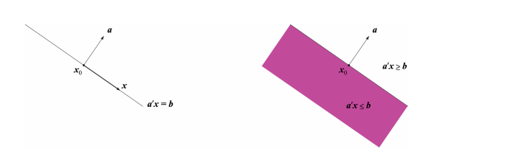

Let $C, D ⊆ R^{n}$ be nonempty convex disjoint sets i.e., $C ∩ D = ∅.$ Then, there exists $a ∈ R^{n}$, $a ≠ 0$, $b∈R$, such that $a^{T}x ≤ b$ for all $x ∈ C$ and $a^{T}x ≥ b$ for all $x ∈ D.$

